# Hibernate Exam – 28 July 2019

# Football Information

You have been employed by the Next Level Technologies Ltd. to finish the database layer, which supports basic functionality like importing data and exporting some results.

## Functionality Overview

The firm has hired you as their application developer, to implement the **database layer**. The application should be able to easily **import** hard-formatted data and **support functionality** for also **exporting** the imported data. The application is called – **Football info**.

Look at the pictures below to see what must happen:

* Home page before importing anything:

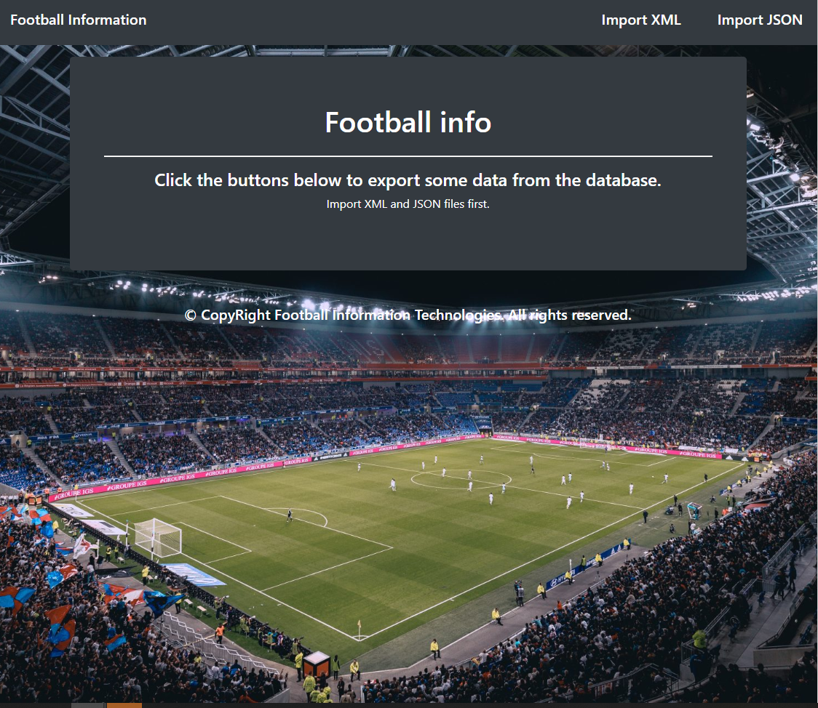

* Import XML page before importing anything:

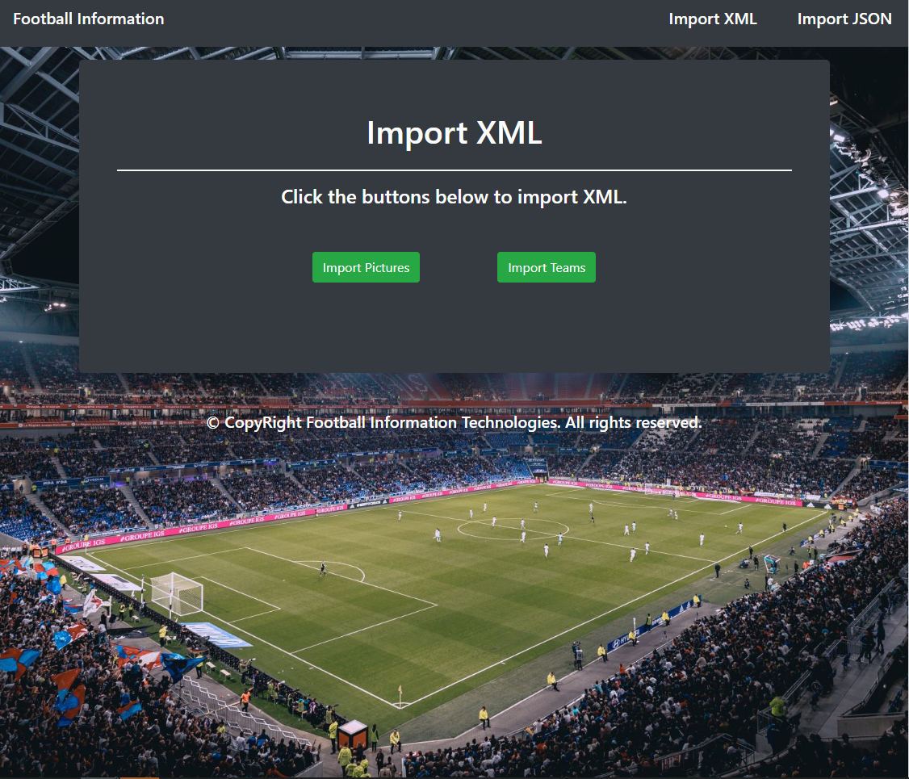

* Import Pictures first:

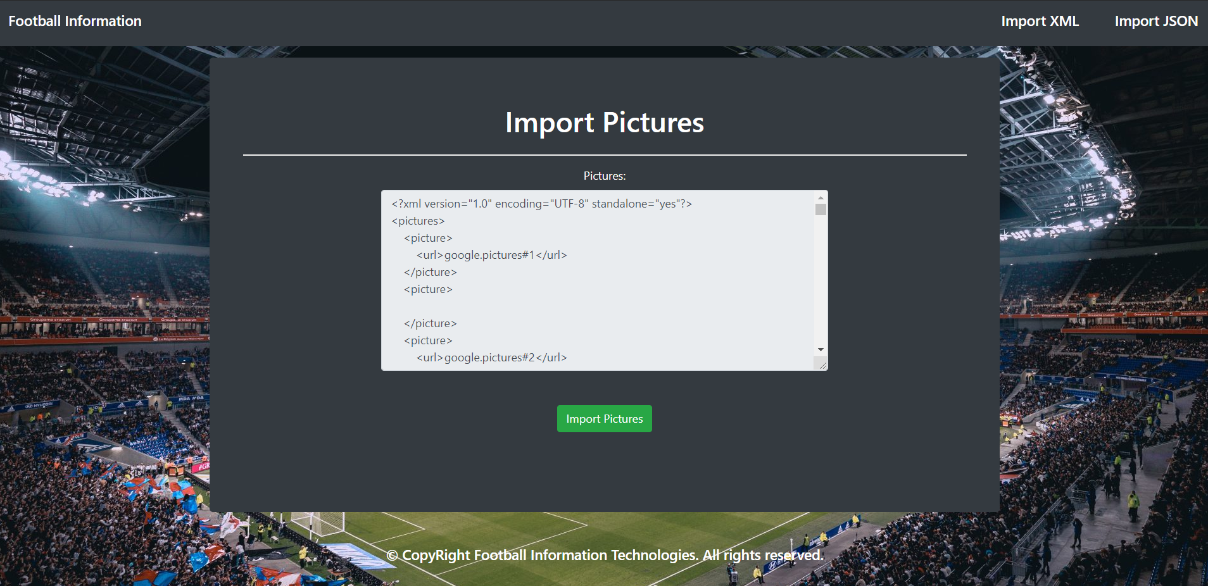

* Import Teams second:

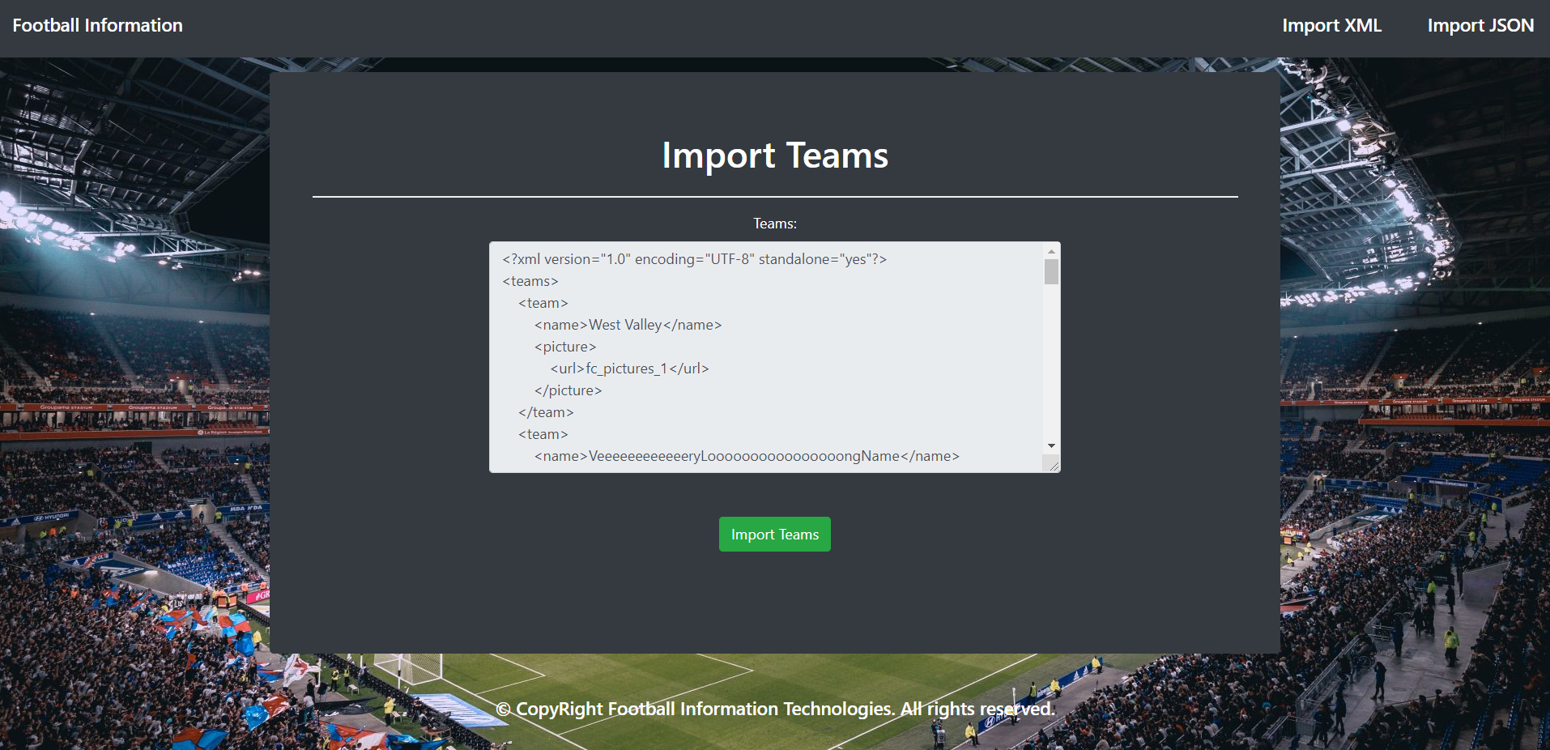

* Import XML page after importing both files:

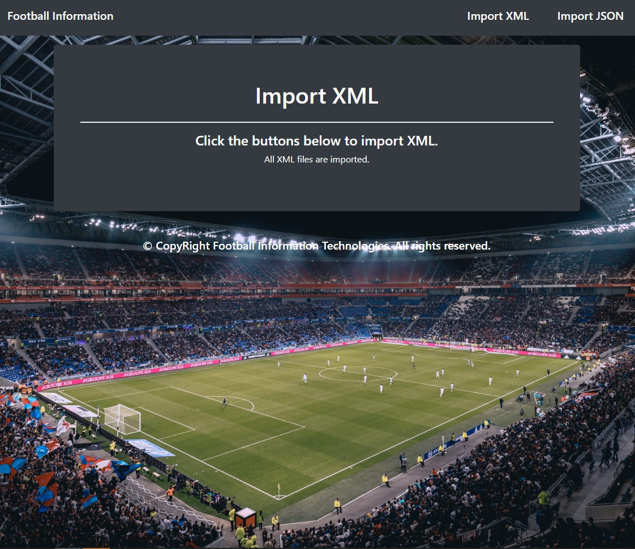

* Import JSON page before importing the given data:

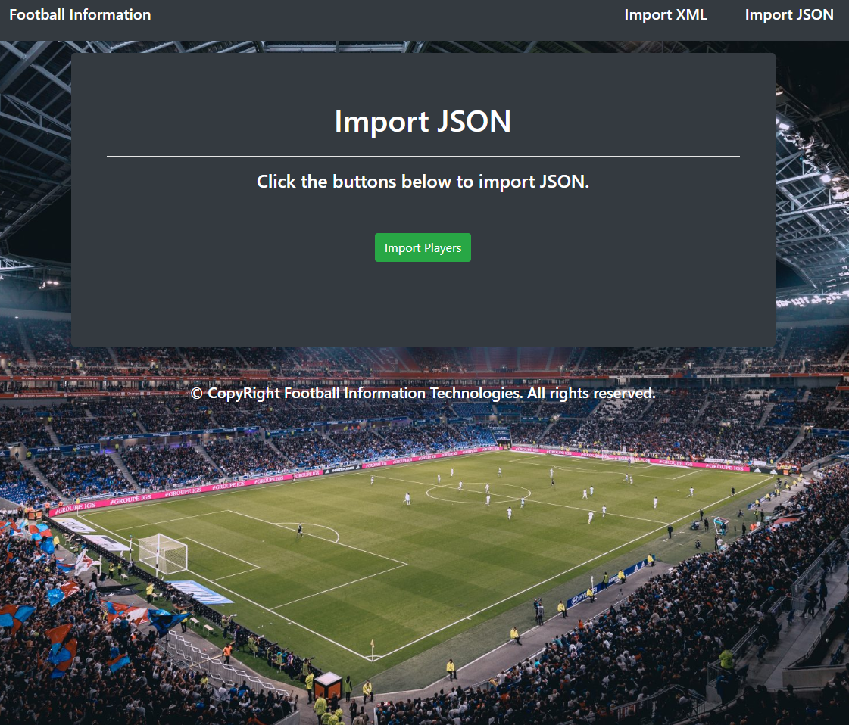

* Import JSON page after importing the data:

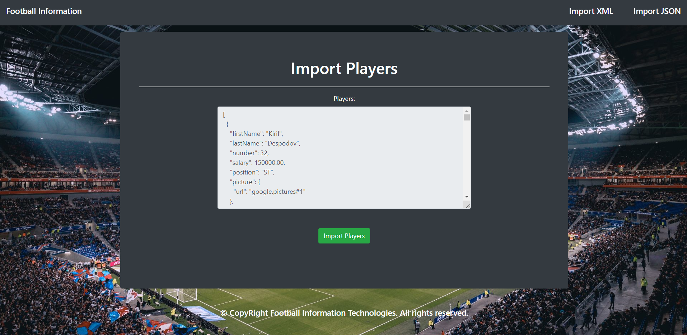

* Import JSON page after importing the data:

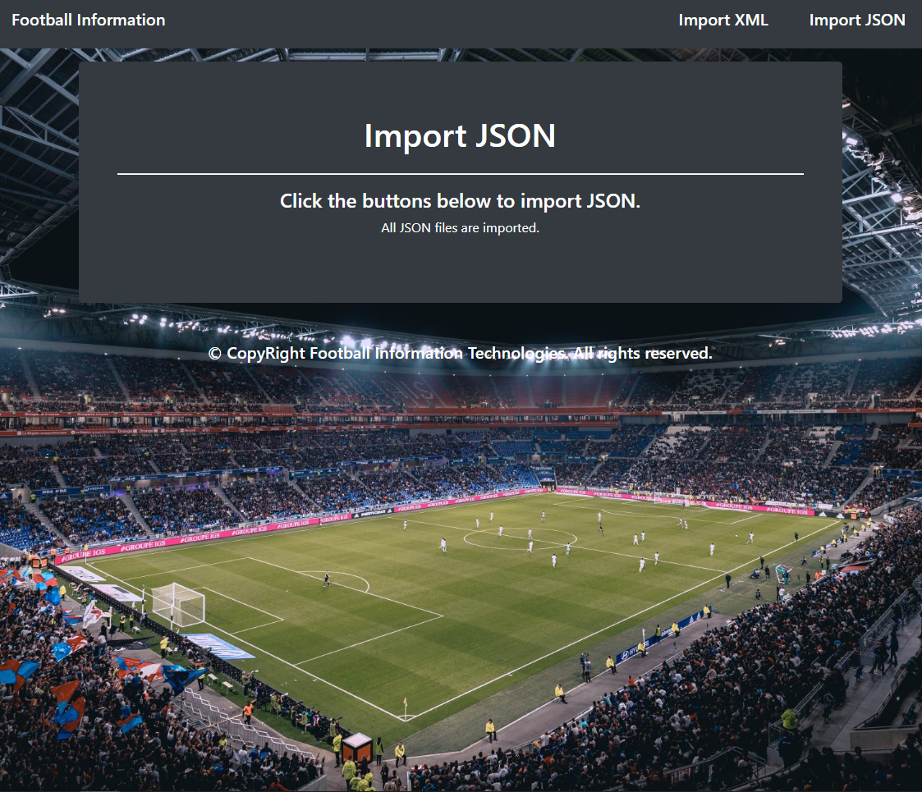

* Home page after the data is imported:

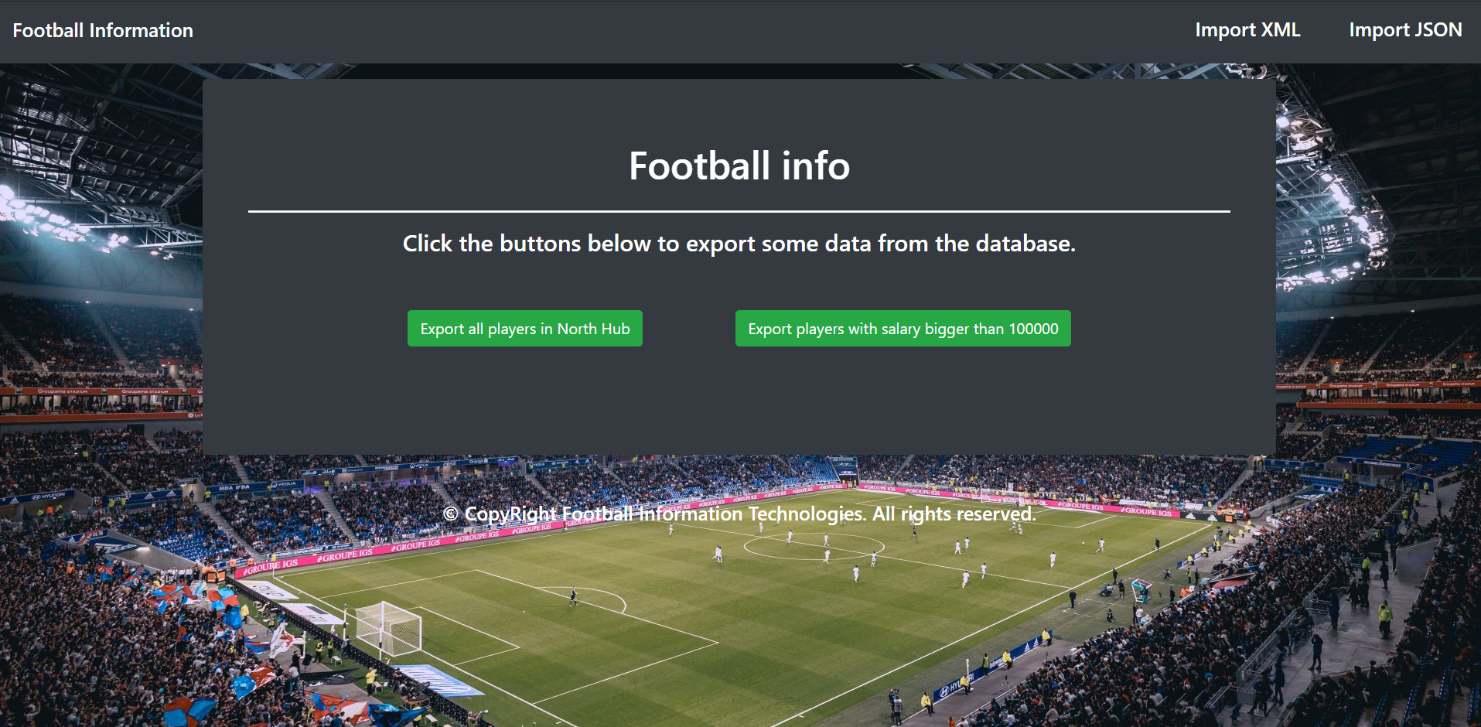

* Export all players in North Hub:

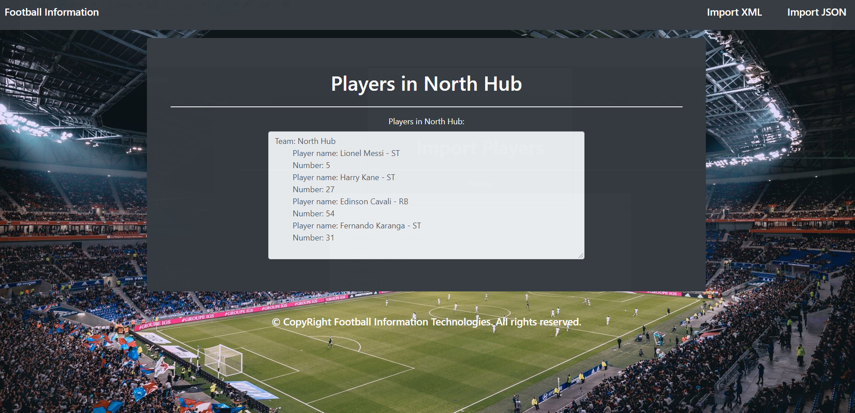

* Export players with salary bigger than 100000:

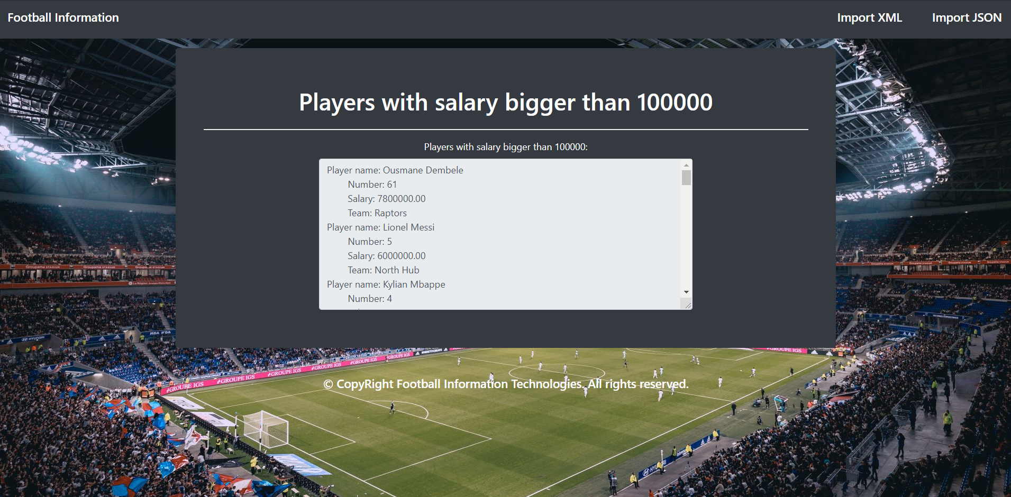

## Project Skeleton Overview

You will be given a **Skeleton**, containing a **certain architecture(MVC)** with **several classes**, some of which – completely empty. The **Skeleton** will include the **files** with which you will **seed** the **database**.

## Model Definition

There are 3 main models that the **Football info** database application should contain in its functionality.

Design them in the **most appropriate** way, considering the following **data constraints**:

### Picture

* id – **integer** number, **primary identification field**.
* url – a **string** (**required**).

### Team

* id – **integer** number, **primary identification field**.
* name – a **string** (**required**) between 3 and 20 characters.
* picture – a **Picture entity** (**required**).

### Player

* id – **integer** number, **primary identification field**.
* first_name – a **string** (**required**).
* last_name – a **string** (**required**) between 3 and 15 characters.
* number – a Integer (**required**) between 1 and 99.
* salary – a Bigdecimal (**required**) min 0.
* position – an **ENUM** (**required**).
  + GK, CD, RB, LB, CM, DM, CDM, LM, RM, ST, CF, RW, LW
* picture – a **Picture entity** (**required**).
* team – a **Team entity** (**required**).

**NOTE**: Name the entities and their class members, **exactly** in the **format stated** above. Do not name them in snake case with the dashes, of course. But if a field is specified as first_name, you are to name it firstName.

#### Relationships

The Football info decided to give you a little hint about the more complex relationships in the database, so that you can implement it correctly.

One Team may have only one Picture, and one Picture may have many Teams.

One Team may have many Players, and one Player may be appointed to only one Team.

One **Player** may have only one **Picture**, and one **Picture** may have many **Players**.

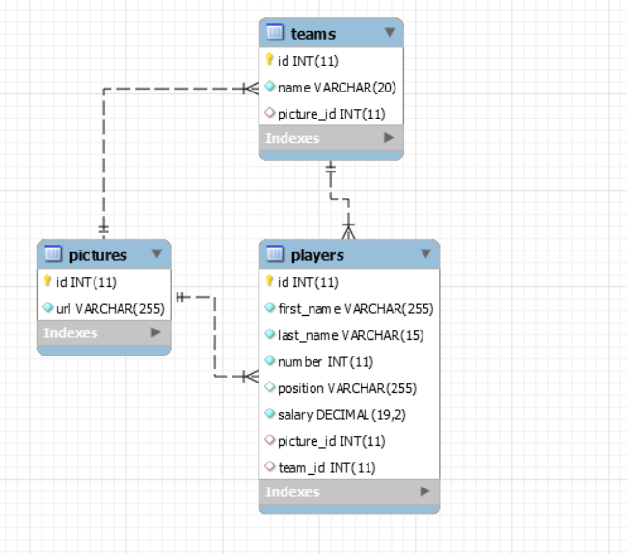

## Data Import

Use the provided files to populate the database with data. Import all the information from those files into the database.

**You are not allowed to modify the provided files.**

**ANY INCORRECT** data should be **ignored** and a message “**Invalid {picture/team/player}**” should be printed.

* **NOTE**: An incorrect data input is an input which is **missing required fields**.

When the import is finished

“**Successfully imported {picture/team/player}- {url/name/firstName lastName}**”

### XML Import

The **Football info** have prepared some XML data for you to import.

#### Picture (pictures.xml)

|  |
| --- |
| **pictures.xml** |
| *<?***xml version="1.0" encoding="UTF-8" standalone="yes"***?>* <**pictures**>  <**picture**>  <**url**>google.pictures#1</**url**>  </**picture**>  <**picture**>   </**picture**>  <**picture**>  <**url**>google.pictures#2</**url**>  </**picture**>  . . .  <**pictures/**> |
| Successfully imported picture - google.pictures#1  Invalid picture  Successfully imported picture - google.pictures#2 |

#### Team (teams.xml)

|  |
| --- |
| **teams.xml** |
| *<?***xml version="1.0" encoding="UTF-8" standalone="yes"***?>* <**teams**>  <**team**>  <**name**>West Valley</**name**>  <**picture**>  <**url**>fc_pictures_1</**url**>  </**picture**>  </**team**>  <**team**>  <**name**>VeeeeeeeeeeeeryLoooooooooooooooongName</**name**>  <**picture**>  <**url**>noPicture</**url**>  </**picture**>  </**team**>  <**team**>  <**name**>Samurai</**name**>  <**picture**>  <**url**>invalidURL</**url**>  </**picture**>  </**team**>  . . . <**teams**> |
| Successfully imported - West Valley  Invalid team  Invalid team |

### JSON Import

#### Player (players.json)

|  |
| --- |
| **players.json** |
| [  {  **"firstName"**: **"Kiril"**,  **"lastName"**: **"Despodov"**,  **"number"**: 32,  **"salary"**: 150000.00,  **"position"**: **"Invalid"**,  **"picture"**: {  **"url"**: **"google.pictures#1"** },  **"team"**: {  **"name"**: **"West Valley"**,  **"picture"**: {  **"url"**: **"fc_pictures_1"** }  }  },  {  **"firstName"**: **"Christian"**,  **"lastName"**: **"Rodrigues"**,  **"number"**: 121,  **"salary"**: 100000.00,  **"position"**: **"RB"**,  **"picture"**: {  **"url"**: **"google.pictures#2"** }  . . . |
| Invalid player  Invalid player  Invalid player  Successfully imported player: Rubin Star  Successfully imported player: Serj Smokey |

## Data Export

Get ready to export the data you’ve imported in the previous task. Here you will have some pretty complex database querying. Export the data in the formats specified below.

#### Export all players North Hub

**Export all players** which are playing in North Hub:

* Extract from the database, the name of the **team** and information about the player ordered by id.

"Team: {Name}

Player name: {playerOne firstName} {playerOne lastName} - {playerOne position}

Number: {playerOne number}

Player name: {playerTwo firstName} {playerTwo lastName} - {playerTwo position}

Number: {playerTwo number}

. . . "

#### Export players with salary bigger than 100000

**Export** all the players with salary bigger than 100000.

* Export the **player’s** **full** **name**, **number, salary and team name order by salary descending.**

"Player name: {firstName} {lastName}

Number: {player number}

Salary: {player salary}

Team: {team name}

. . ."